Westchester County needs over 13,000 to 27,000 Affordable Housing units to meet demand: Current production of new affordable housing is not adequate to meet this demand.
Westchester County Affordable Housing Supply Gap Analysis
Renter Occupied units | 148,212
For Rent | 7,483
Rented, not occupied | 1,029
Total Rental units | 156,724
Affordable to 30% AMI |  | 15,594
Affordable to 50% AMI |  | 23,524 |  | GAP
0-30% AMI households 1+ housing problems |  |  | 33,905 | -18,311
30-50% AMI households 1+ housing problems |  |  | 18,670 | 4,854
 |  |  |  | -13,457
 |  |  |  | GAP
0-30% AMI households |  |  | 42,580 | -26,986
30-50% AMI households |  |  | 23,910 | -386
 |  |  |  | -27,372
Sources: 2022 American Community Survey (ACS), Comprehensive Housing Affordability Strategy (CHAS) data 2016-2020, CPD Maps https://egis.hud.gov/cpdmaps/

Westchester County CoC needs PSH turnover of at least extra 20 units each year
(or one-time production of 200 additional units)
FY2023 | ES | Street Outreach | Street Outreach-CV | TOTAL
Disabled and 12+ months homeless at entry or during FY (= Max PSH Need - often not documented time) | 277 | 38 | 43 | 358
counting only time in ES/ SO  (= Minimum PSH Need) | 81 | 5 | 14 | 100
exits from PSH |  |  |  | 83
move-ins to PSH |  |  |  | 76
Est. annual turnover (= PSH Supply) |  |  |  | 80
PSH GAP - Maximum |  |  |  | -278
PSH GAP-Minimum: counting only documented time in ES/ SO |  |  |  | -20
PSH turnover currently about 80 units per year for 100 households (counting only time in current shelter) or 358 households using months homeless entered at Coordinated Entry enrollment.

Westchester County CoC has sufficient Rapid Rehousing to meet current demand
FY2023
CHAT assessment completed | 3,404
& not disabled | 3,015
& RRH CHAT 8+ (= RRH Need) | 109
exits from RRH | 146
move-ins to RRH | 130
Estimated annual turnover (= RRH Supply) | 138
RRH GAP | 29
- Westchester has sufficient RRH to house all households with 8+ CHAT without disability.
Stella P shows families (especially those with 3+ children) have average Length of Time Homeless significantly longer than other population groups.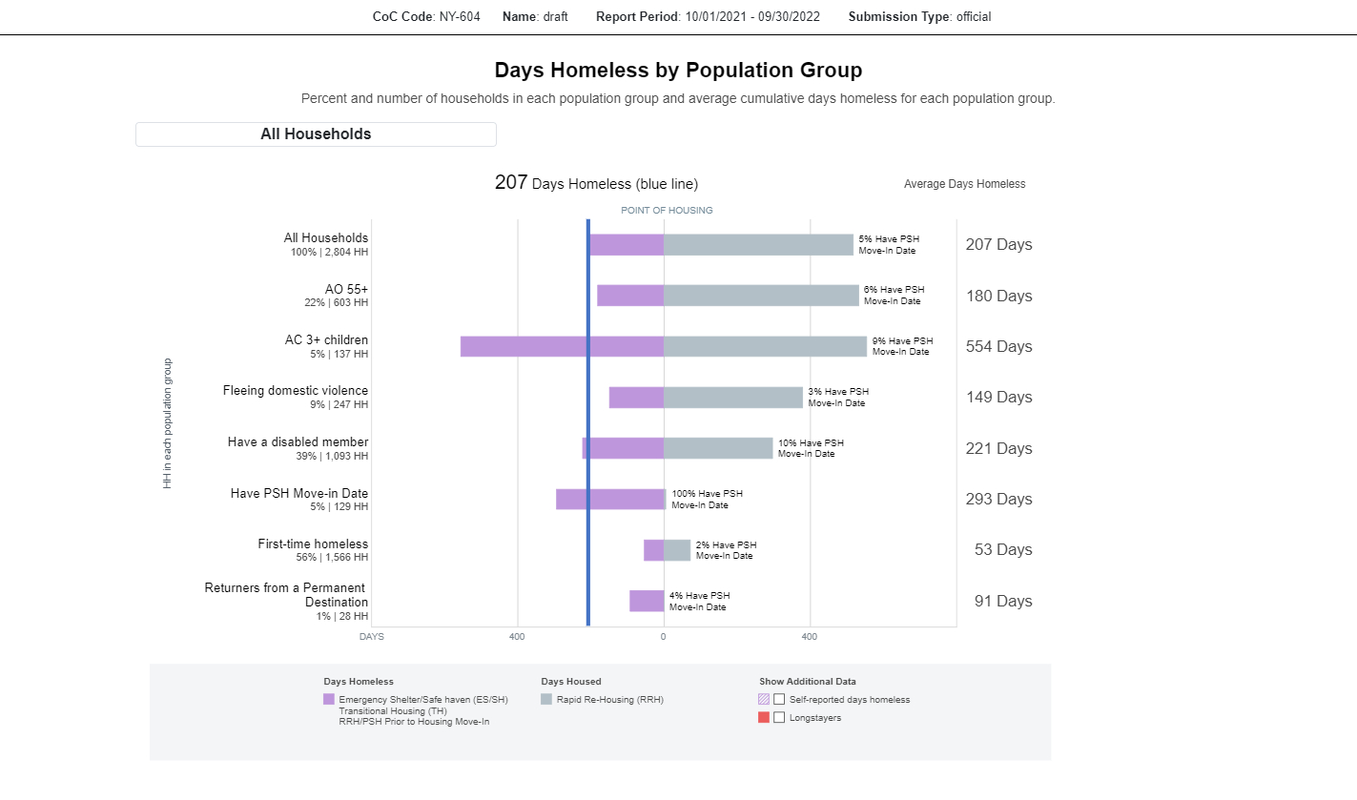

Type of Head of Household | # of Households | Average Days Homeless
Families With 3+ Children | 137 | 554 Days
All Families With Children | 625 | 456 Days
Have a PSH Move-In Date | 129 | 293 Days
Have a Disabled Member | 1,093 | 221 Days
AVERAGE for All Households | 2,804 | 207 Days
Aged 55+ | 603 | 180 Days
Fleeing Domestic Violence | 247 | 149 Days
All Adults Only | 2,089 | 142 Days
Returners From a Permanent Destination | 28 | 91 Days
First-Time Homeless | 1,566 | 53 Days

